Objectives:

* Java Applets

**There are 7 print screens/code copy, each worth 14.2 %**

**Project #1 (Connecting using Access Database) + JApplet**

Note: Download the (Access Drivers) zip files drivers and import them into the Library

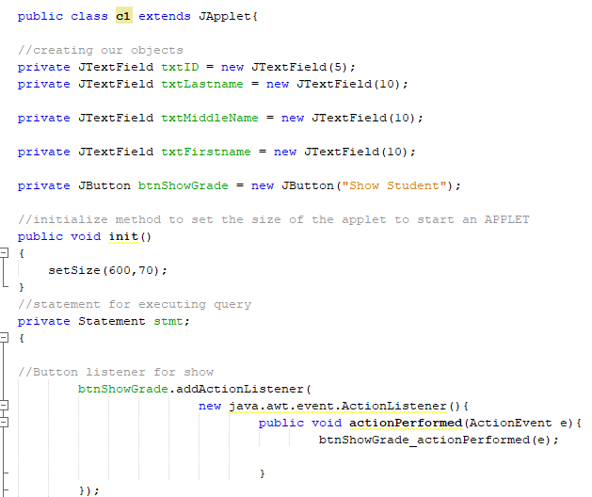

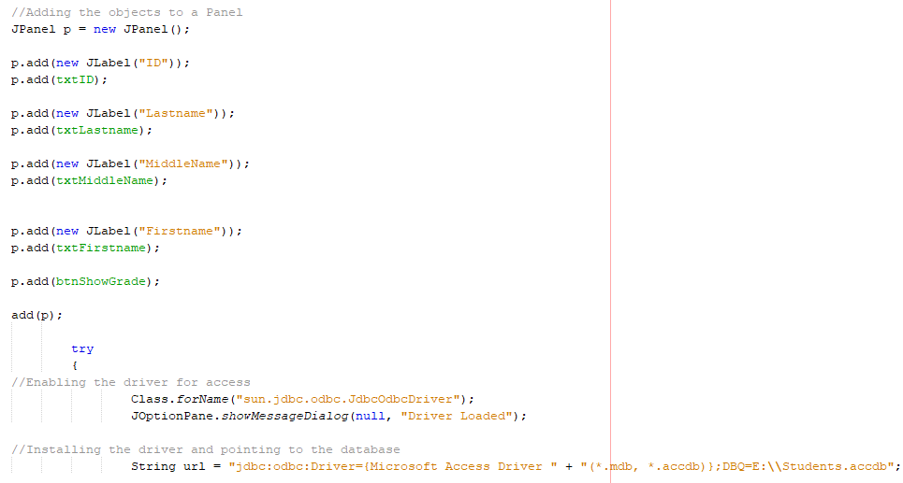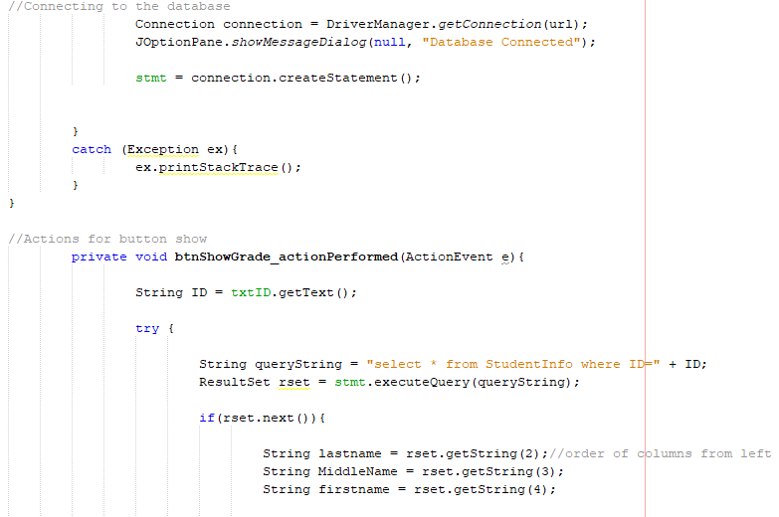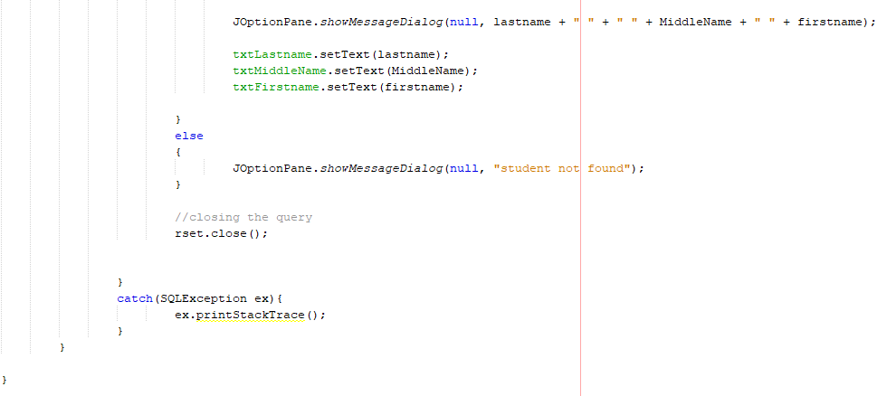

**#1 print screen the applet below here**

**#2 copy and paste the code below here**

**Project #2**

Extending from Exercise #1, add the following fields to the applet:

*Address, City, State, Zipcode*

Ensure to add additional field names on the access table that will connect to the new fields

**#3 print screen the applet below here**

**#4 copy and paste the code below here**

**#5 print screen the access table below here**

**Challenge Exercise**

Create a new applet below: GO TO NEXT PAGE…..

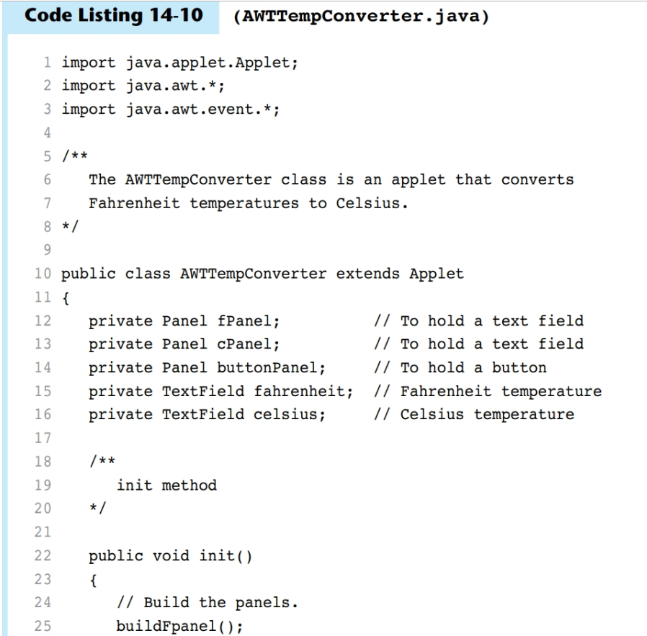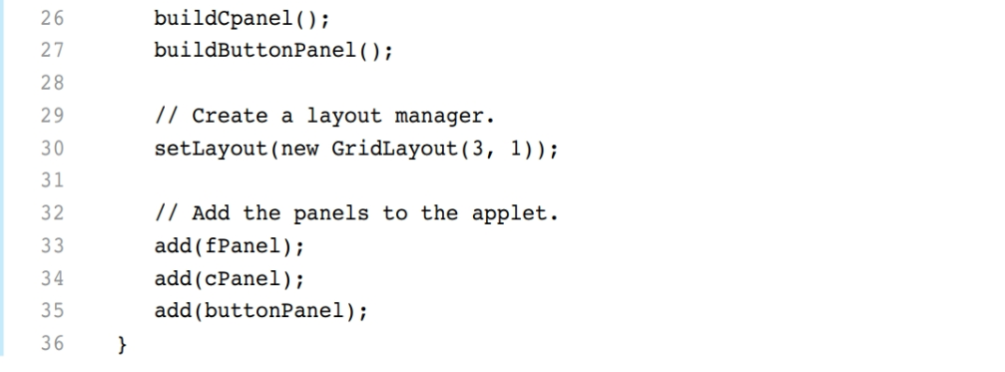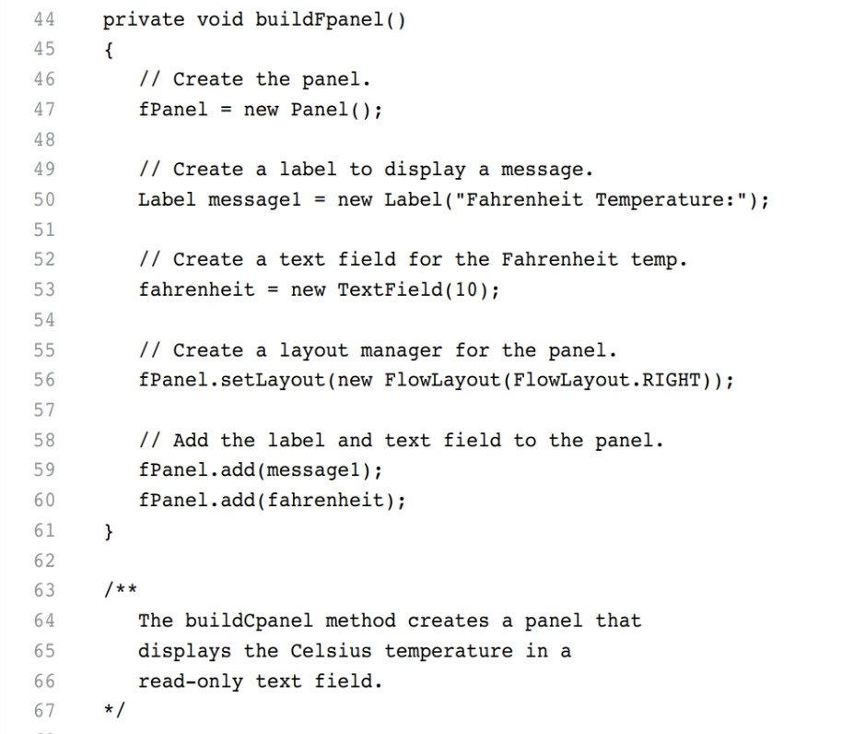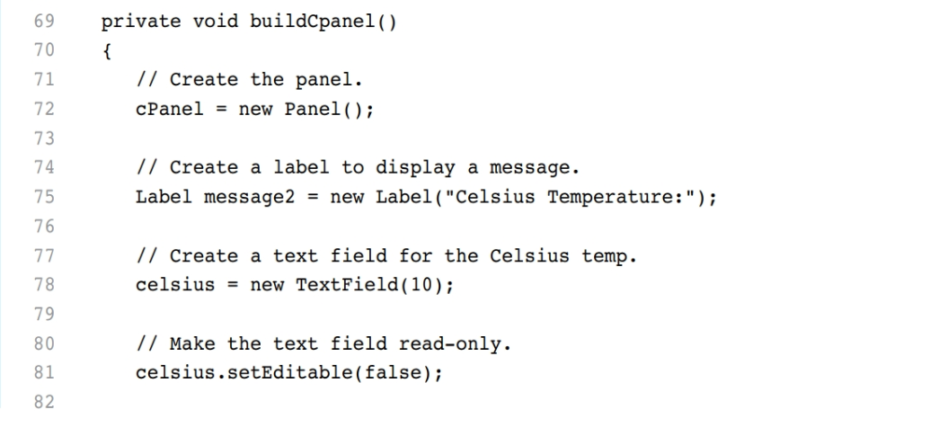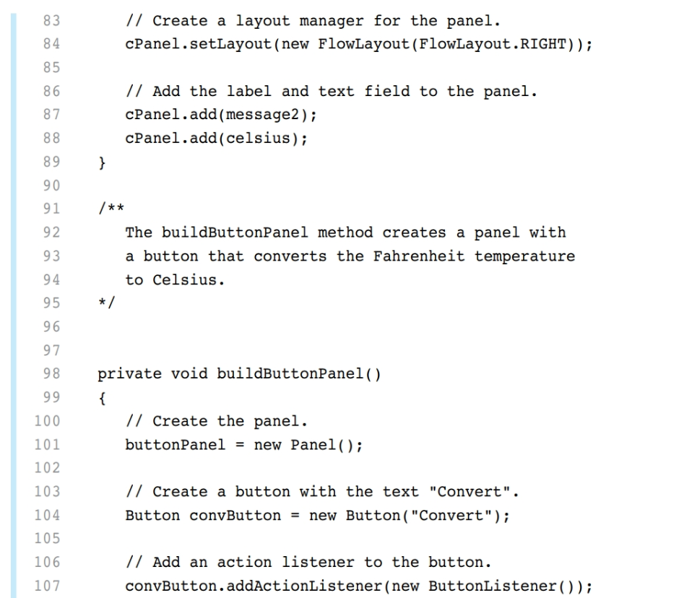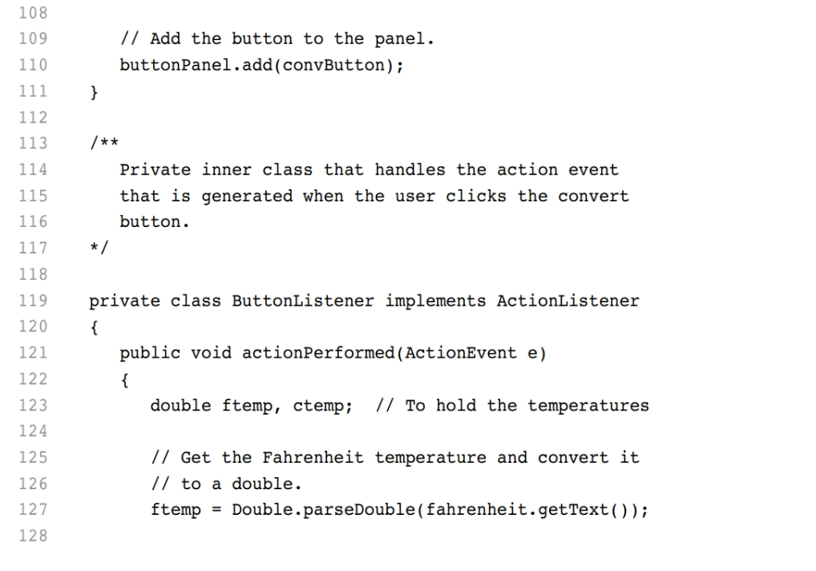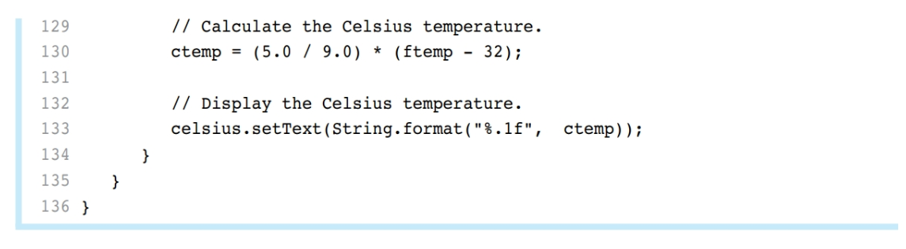

**#6 print screen the applet below here**

**#7 copy and paste the code below here**

**Submit this document to Module 10 Class Exercise #8**